**EXP NO 1**

**CREATE A SIMPLE CLOUD SOFTWARE APPLICATION AND PROVIDE IT AS A SERVICE USING ANY CLOUD SERVICE PROVIDER TODEMONSTRATE SOFTWARE AS A SERVICE (SAAS).**

DATE:

AIM:

To create a simple cloud software application and provide it as a service using any cloud service provider todemonstrate software as a service (saas).

PROCEDURE:

STEP1: GOTO ZOHO.COM

STEP 2: LOGIN TO THE ZOHO.COM

STEP 3: SELECT ONE APPLICATION

STEP 4: ENTER APPLICATION NAME

STEP 5: CREATED NEW APPLICATION

STEP 6: SELECT ONE FORM

STEP 7: THE SOFTWARE HASE BEEN CREATED.

IMPLEMENTATION:

Here is the form to fill the details.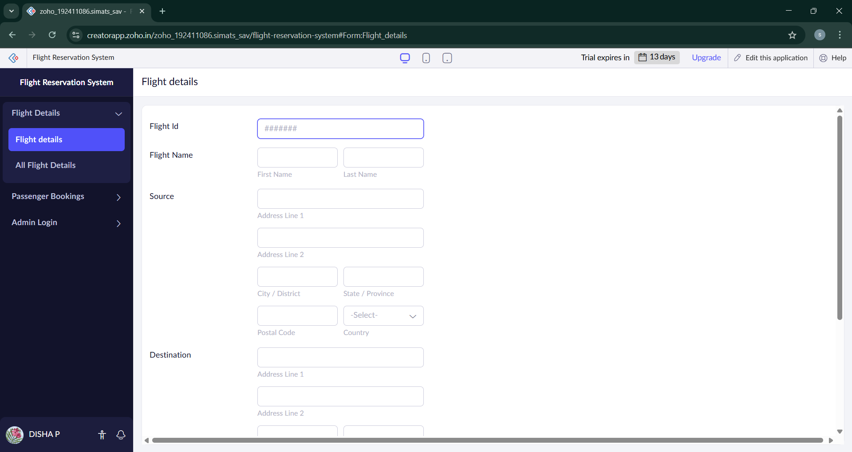

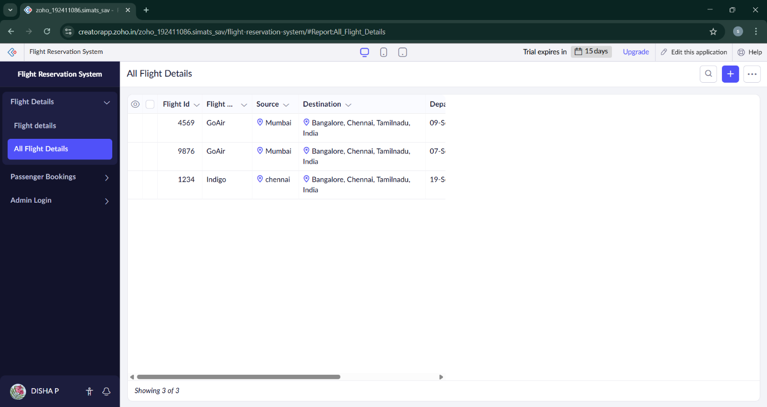

The details are filled here.

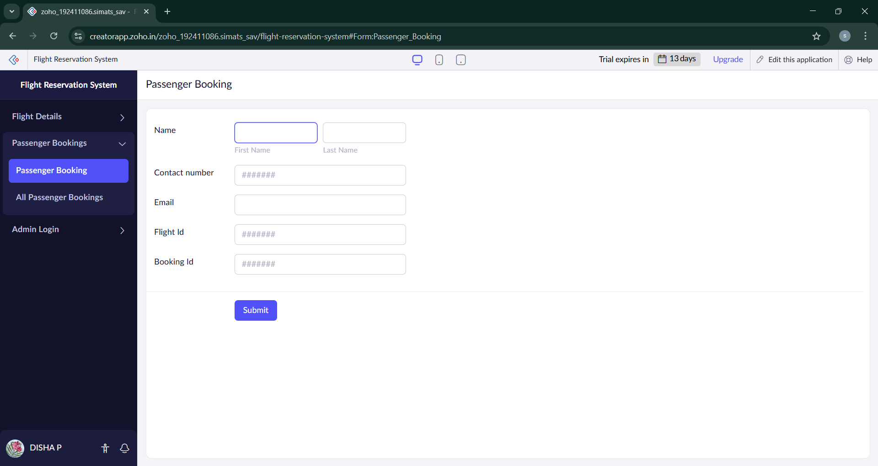

Now here passenger booking is done.

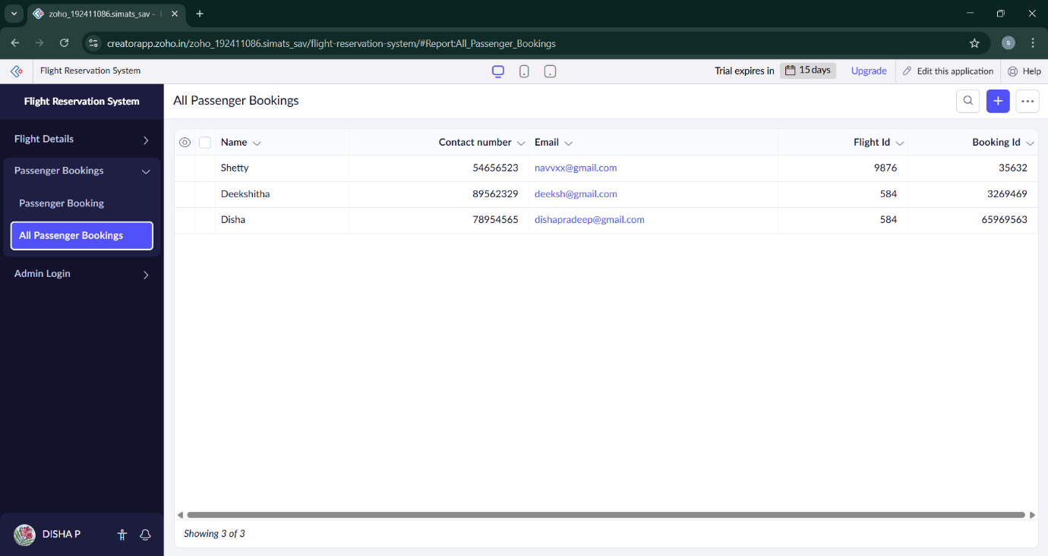

The details are filled.

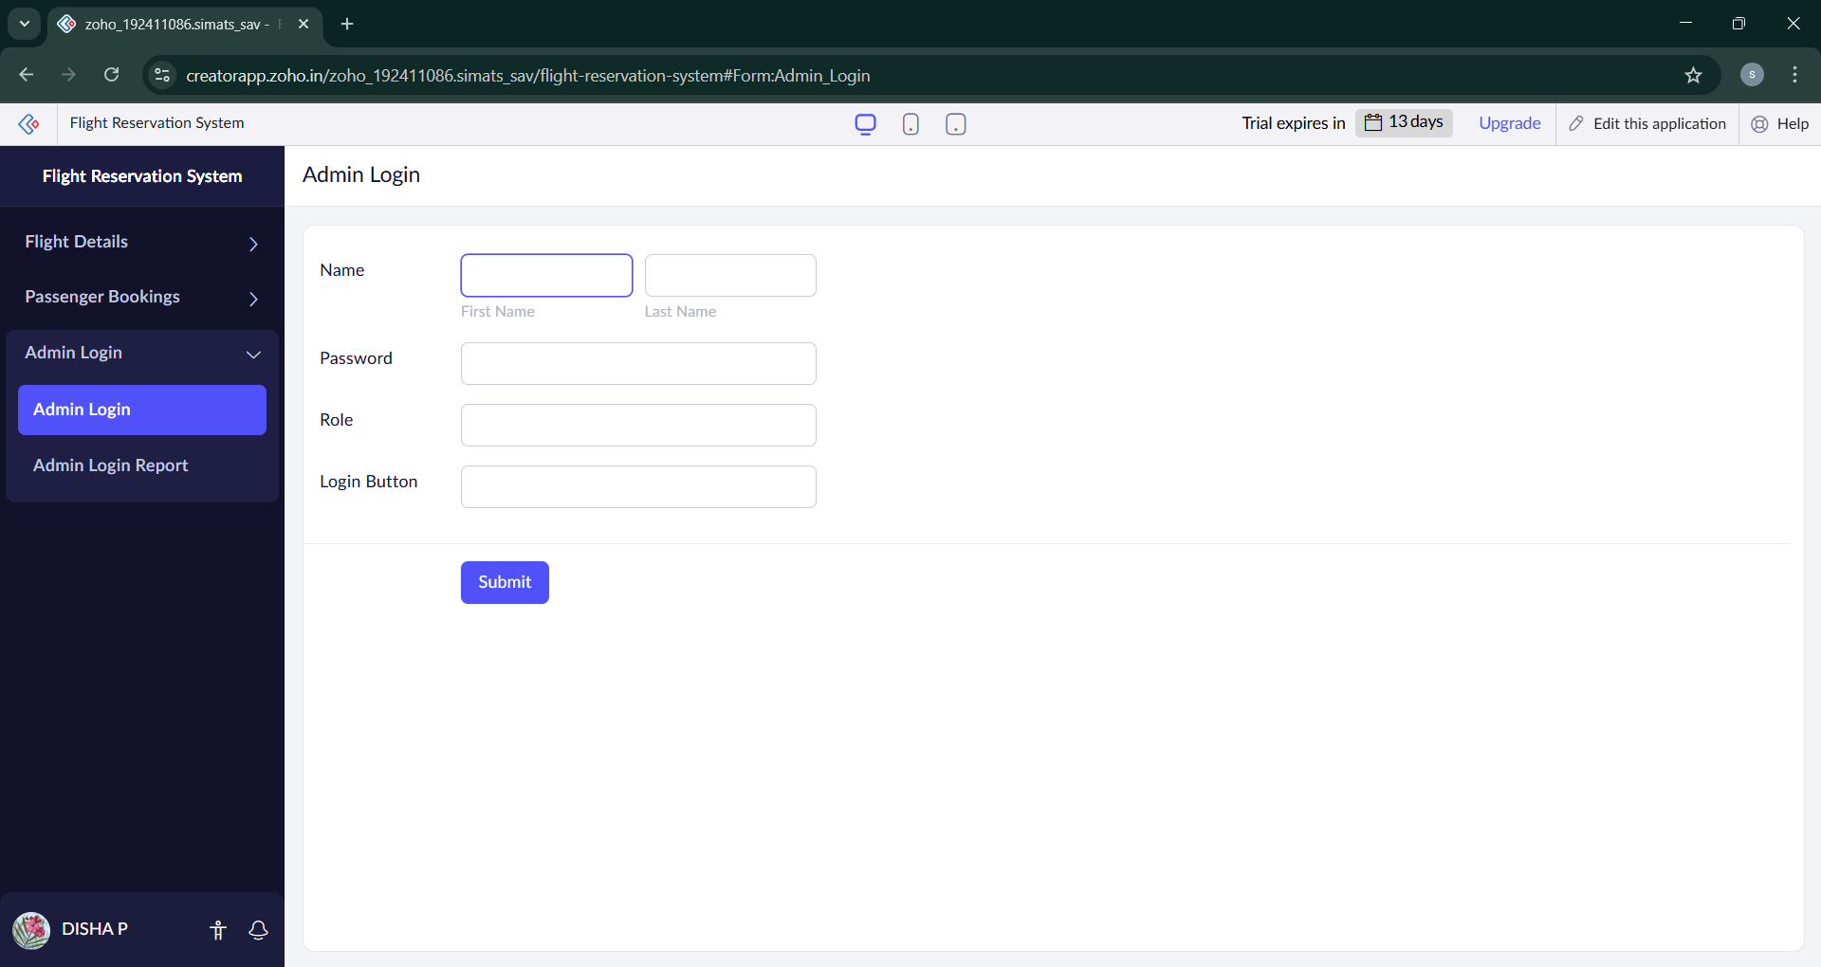

Now the Admin Login form has been formed.

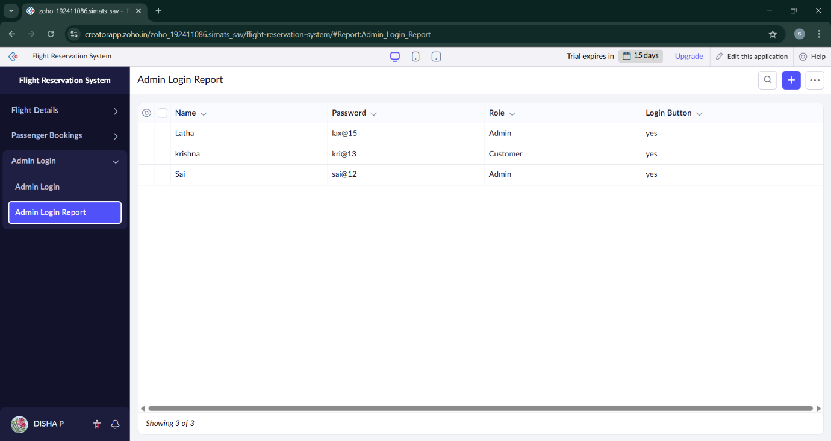

The details are filled here.